Heating and Air Conditioning Heat Transfer Coils
Installation, Operation, and Maintenance Instructions for HVAC and Process Coils

www.coilcompany.com
(800) 523-7590 (610) 251-0257

Coil Company
P.O. Box 956
Paoli, PA 19301

Heat Exchanger Coils
General
Heat Exchanger Coils are not very complex to install, considering there are no movable parts. They usually are shipped intact and there is almost never any assembly at the coil installation site.
There are several points discussed below to ensure that the coil installation and maintenance are performed in a manner to guarantee satisfactory life.
Shipping and Receiving
There are various sizes of coils. Crating methods differ depending on coil dimensions and weight. There are typically two types of crates; the vertical type and the horizontal type.
Coils that weigh less than 2,000 lbs. or are not very large in width and/or length, are crated vertically. Coils that are very wide are concealed in the flat horizontal crate.
All crates provide and area for a forklift or mechanical lifting. Coils are very fragile and must be handled with extreme care. Unless specified on the order, a crate is not built to be turned on end. Try not to uncrate a coil until it has arrived at the unit or area of installation.
When uncrating a coil, be sure to disassemble the crate around the coil and do not drop the coil out of the crate.
Installation into Unit
Always lift a coil into place around the casing, never by the return bends, headers, or connections of the coil. These areas will rupture or distort, and the coil can be severely damaged. All Coil Company coils normally have bent-over stacking flanges for mounting on top of each other; the flange is 1/2” on small coils and 3/4” on larger coils.
Piping Recommendations- General
A- Support all piping independently of the coil.
B- All coil connections usually extend through the side wall of the unit or area containing the coil. Usually vent and drain connections are still within the wall of the unit.
C- All connections next to heating coils should have swing joints or flexible fittings to absorb expansion and contraction strains.
D- Install all piping in accordance with local codes and accepted industry standards.
Piping Recommendations- DX Coils
A- The expansion valve (by others) should be externally equalized unless specified otherwise. Locate the DX valve bulb on a horizontal section of the suction line just below the valve.
B- Suction lines should be sloped toward the compressor to allow good oil return.
C- Suction risers of more than 5 feet should be trapped at the bottom.
D- Evacuate the system to remove moisture and non-condensibles. Leak test all connections before charging the system.
Piping Recommendations- Water Coils
A- Always use a back-up wrench when making coil connections to prevent damage to the coil. Excessive stress could break the weld joint at the header or at the adapter tubes.
B- Any water coil should not have a modulating design if the coil air temperature might be below freezing (under 32°F.). Water will be trapped in the coil and major freeze damage can occur.
Piping Recommendations- Steam Coils
A- Steam coils must always be pitched toward the condensate connection, at least 1/8” per linear foot of tubing. If this was not built into your coil design, then you must pitch it in the field.
B- Always use a back-up wrench (See “A” in Water Coils).
C- Insulate both steam and condensate piping.
D- Proper piping methods must be used to remove condensate and to allow for steam flow. It is very important that coils are vented properly, have full size piping, and have traps and vacuum breakers sized and located properly. The traps should be located at least 12” below the coil condensate outlets.
E- When the entering air temperature is going to be near or below freezing (32°F.) then the following is necessary:
1. A minimum of 5 PSIG steam pressure must always be maintained.
2. Face and bypass damper to control temperature should be used in lieu of a modulating system.
3. Always feed the coil with steam for 10 to 15 minutes before outside air is introduced.
4. There must be controls in place for shutting down systems if the condensate is trapped in the coil and the air temperature is below freezing.
Freeze Protection Methods for Coils
Coils subjected to freezing temperatures cannot be adequately protected by simply draining the coil. Low tubes in each circuit will remain filled with water and burst open upon freezing.
Two accepted methods of protecting coils from freezing are:
1. Using an air blower
2. Adding an adequate antifreeze solution
Using an Air Blower
To use this method, a blower capable of producing 150 CFM at about 45 inches of water is required. The blower outlet will have to be field adapted to the threaded coil connection.
When blowing out a coil, use the following procedure and refer to Figure 1.
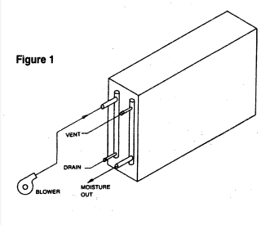
1. Turn off the water supply.
2. Remove the vent and drain caps and allow the coil to drain.
3. Replace the vent/drain caps and remove the supply/return piping from the coil connections.
4. Connect the blower outlet to the return (top) connection as shown. Be careful not to place excessive stress on the connection or damage to the coil may occur.
5. Blow air through the coil for about 30-45 minutes. Tap the top or bottom of the air handler along the length of the coil area to help remove trapped water.
6. Place a mirror in front of the supply connections (bottom) to see if all the moisture is removed. Any moisture still being removed from the coil will fog the mirror.
7. Once the air appears to be moisture free, turn the blower off and allow the coil to stand about 10 minutes to permit any water remaining on the inside tube walls to drain down.
8. Start the blower again and if any moisture is being removed, repeat the procedure again.
9. Do not reconnect the supply and return piping until the coil is ready to be returned to operation.
Addition of Antifreeze Solution
A corrosion inhibited antifreeze solution should be circulated through the coil for best results. Consult the manufacturer’s information about the freezing points of different concentrations to determine the best solution and the lowest cost.
For best results use a circulating pump and runaround loop between the coil and the solution container.
Use the following procedure while referring to Figure 2.
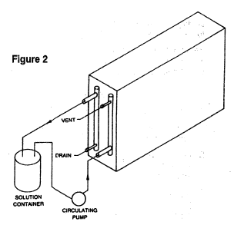
1. Repeat steps 1-3 above.
2. Connect the circulating pump to the supply (bottom) connection and the return line to the return (top) connection.
3. Circulate the solution for about 20 minutes.
4. Check the solution with a hydrometer. If the freezing point is not as low as desired, add additional antifreeze to the solution container and repeat the procedure.
5. The antifreeze may be left in the coil or removed to be used on another coil.

