Air Handlers
Installation, Operation, and Maintenance for Outdoor Air Handlers

www.coilcompany.com
(800) 523-7590 (610) 251-0257

Coil Company
P.O. Box 956
Paoli, PA 19301

Model Number Designation
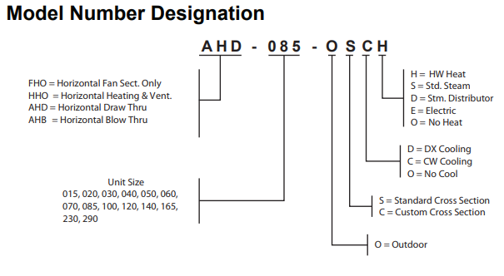
General Information
The system design and installation must follow accepted industry practice, such as described in the ASHRAE Handbook, the National Electric Code, and other applicable standards. The installation of this equipment must be in accordance with regulations of authorities having jurisdiction and all applicable codes. It is the responsibility of the installer to determine and follow the applicable codes.
Installation and maintenance must be performed by qualified personnel familiar with applicable codes and regulations and experience with this type of equipment. Sheet metal parts, self-tapping screws, clips, and such items inherently have sharp edges, and it is necessary that the installer exercise caution.
CAUTION: SHARP EDGES AND COIL SURFACES ARE A POTENTIAL INJURY HAZARD. AVOID CONTACT WITH THEM.
Receiving and Handling
1. Carefully check items against the bills of lading to verify all crates and cartons have been received. Carefully inspect all units for shipping damage when received. Report damage immediately and file a claim for damage with the carrier.
2. Coil Company air handler units are constructed of heavy-gauge galvanized steel and are thoroughly inspected before leaving the factory. Care must be taken during installation prevent damage to the units.
3. Take special care when handling the blower section. All fans are dynamically balanced before leaving the factory. Rough handling can cause misalignment or damaged bearings or shaft. Carefully inspect fans and shaft before unit installation to verify this has not happened.
4. If necessary, screws, bolts, etc., for assembly of sections are supplied in a bag attached to each section. All necessary gasketing is applied in the factory for section to section mounting. Units require caulk sealant between sections.
Unit Storage
Store unit on a level surface. If air handling units are to be stored for any period, it is important to periodically rotate the fan wheel. The wheel should be rotated to prevent permanent distortion of the drive components. Grease may settle in the lower part of the bearing, which can lead to oxidation on the upper portion of the bearing surface. It is also important to keep the fan bearings lubricated.
Installation Guidelines
Service Clearances
In addition to providing adequate space around the unit for piping coils and drains, access is always required on at least one side of the unit to allow for regular service and maintenance. Filter replacement, drain pan inspection, cleaning, fan bearing lubrication, and belt adjustment are examples of routine maintenance that must be performed. Sufficient space must also be provided on the side of the unit for shaft removal and coil removal if necessary. Space at least equal to the length of the coil is required for coil removal.
See (Figure 1) for servicing space requirements.
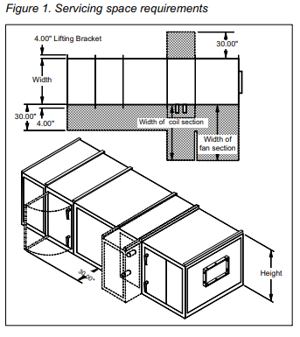
At least 54” of clearance must be maintained in front of electrical power devices. Electrical power devices that are mounted on the side of the unit are typically up to 12” deep (Figure 2).
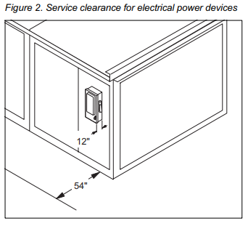
Rigging (Figure 3)
Coil Company air handlers ship completely assembled, or in sections. The unit must be rigged as it ships from the factory. DO NOT RIG UNITS AFTER ASSEMBLY. Units are provided with a factory installed base rail and can be lifted using the 2” diameter lifting holes located in the corners of each shipping section.
To prevent damage to the unit cabinetry, use spreader bars. Spreader bars must be in position to stop cables from rubbing the frame or panels. Before hoisting into position, test lift for stability and balance. Avoid twisting or uneven lifting of the unit.
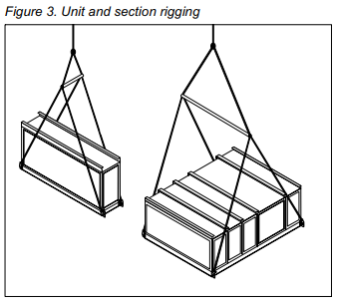
Curb Mounting and Leveling
Do not place a Coil Company unit over an open curb unless it is equipped with a curb-ready base. Installation instructions for mounting units on a roof curb are provided is this manual.
Make provisions under the unit to divert any moisture from entering the building below.
For units without roof curb mounting, place the equipment on a flat and level surface. Where surface irregularities exist, shim the base of the unit at one or more points along the length of the rails to prevent distortion or sagging. Uneven or distorted sections will cause misfit or binding of the doors and panels and improper draining of the drain pans (Figure 4).
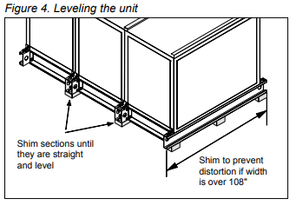
Section Assembly
If the unit is shipped in more than one shipping section, rig each section into position separately. Shipping sections are provided with a connection splice joint attached on the leaving air side of the shipping section that seals against the frame channel on the entering-air side of the adjoining section. The splice joint is insulated and provides an air-tight seal between two sections once they are assembled together. The splice joint must be aligned to seat into the mating gasket to provide an air seal. If the splice joint was bent during shipping or rigging, verify it is restored to its original position (Figure 6).
Use the following procedure to assemble shipping sections:
1. Caulk all assembly joints of the unit. The mating faces of the cabinet must have at least 1/4" diameter bead of sealant applied before the sections are joined. Use the splice joint as a guide for application of the sealant (Figure 5).
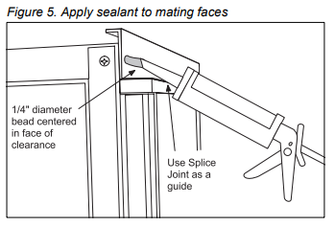
2. Pull the sections together to fasten. Use straps and a ratchet to help pull the sections together securely. Apply sealant to any gaps that may admit moisture.
3A. Fasten the base rails together first using the 3/8”-16 by 5” bolts found in the splice kit provided with the unit (Figure 6). To fasten two shipping sections together, 4 bolts are needed (2 on each side of the unit). The bolts are run from one base rail into the other and fastened with a nut. Complete each section bottom and top before attaching additional sections.
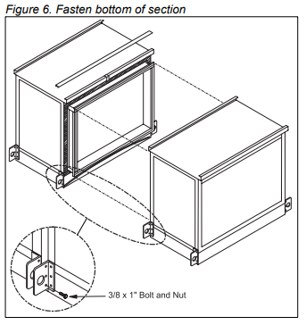
3B. If desired, shipping sections for non-curb ready units can be fastened together internally. Internal fastening is achieved by running field provided #10 sheet metal screws or drill screws (4” long maximum) through the interior frame channel of one unit into the splice joint of the neighboring section (Figure 7).
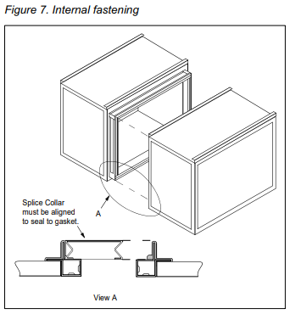
3C. Units with curb-ready bases and vestibules must be handled so that the lifting bracket can be removed after the unit is placed on the curbing. Remove the lifting bracket that projects inward over the curbing. Save the self-tapping screws. When the adjacent section is placed in position, use a self-tapping screw to secure the bases together (Figure 8).
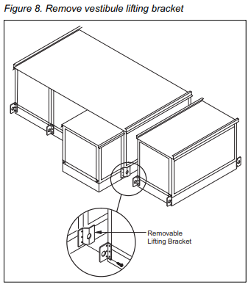
4. Check that the sealant is compressed between the mating channels when the unit sections are joined. Touch up any places where gaps are noted. After sections are seated tightly together, slip the splice cap over the top panel flanges. Bend the ends of the splice cap down to secure in place. Assemble the small splice plate at the top rail to secure the sections together at the top. Use 5/16” bolts (Figure 9).
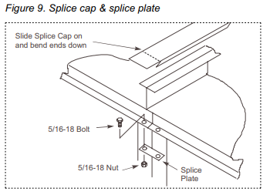
Access Doors and Panels
For routine maintenance, access is normally obtained through access doors or by removing side panels. Removing all flat head fasteners along the sides of a panel will allow it to be removed.
Fan and filter sections are always provided with a service door on one side of the unit. If requested on order, doors can be provided on both sides of the unit. Optional service doors are available for most section types and are provided based on customer request.
Note: Opening fan section doors requires the use of 1/2" socket wrench. This satisfies ANSI standards and other codes that require the “use of tools” to access compartments containing moving parts or electrical wiring (Figure 10).
1. Remove the padlock if one is present. CAUTION: DO NOT ATTEMPT TO ROTATE THE CUP. DAMAGE TO THE UNIT WILL OCCUR.
2. Insert 1/2" socket into the cup and rotate 1/4 turn clockwise as shown in (Figure 10). If the cup and handle are on the left side of the door, rotate 1/4 turn counterclockwise.
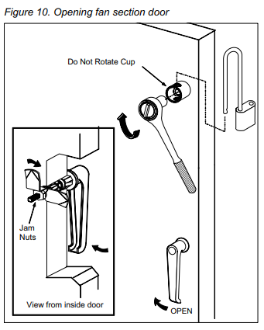
3. Rotate the door handle 1/4 turn clockwise, then 1/4 turn counterclockwise to release any internal pressure or vacuum and open the door. If the cup and handle are on the left side of the door, rotate the door handle 1/4 turn counterclockwise, then 1/4 turn clockwise.
4. To prevent air leakage, tighten the door panels by adjusting the jam nuts.
Duct Connections
Flexible connectors should be used on the outlet and inlet duct connections of all units. Do not position down flow fans over air ducts that are routed down into the building. A discharge plenum is recommended when bottom connections are necessary (Figure 11).
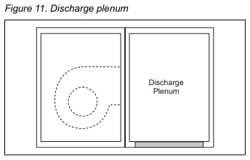
If the unit has a top mixing box or economizer damper, or a top duct connection, flashing must be field fabricated and installed to divert moisture from the connection. The flashing must lap over the standing seams of the top panels. The flashing must also lap over the side edges of the unit (Figure 12).
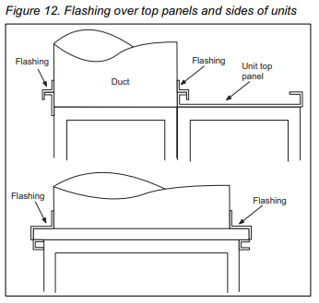
Dampers and Hoods
Side dampers may be provided in the mixing box and economizer sections of the units. When dampers are provided, a removable panel is located above the weather hood to provide access to the damper drive shaft. Other access may be available depending on the specific construction of the unit (Figure 13).
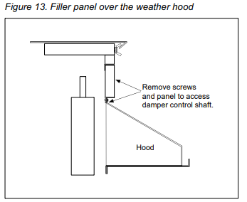
When units are ordered with exhaust hoods and intake hoods adjacent to each other, a field supplied barrier is recommended to prevent re-circulation of exhaust air into the intake openings (Figure 14).
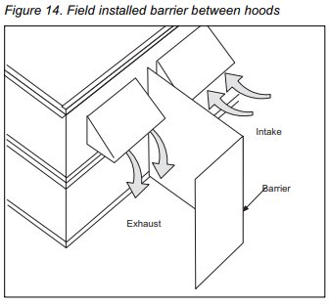
Mounting Actuators
The installing contractor is responsible for the mounting of all field installed actuators. No provisions are made for the location of these actuators due to the number of options and arrangements available and the variety of specific applications. Typically, actuators are mounted inside the cabinet. Provide proper support for the actuator to avoid excessive stress in the cabinet, linkage, or damper shafts.
Note: Damper blades are at full flow when open to 70 degrees. Do not open the blades further than 70 degrees.
Fresh air and return are dampers can be linked together and driven from the same actuator if the dampers are the same size. If the dampers are different sizes, they must be driven by separate actuators and controlled appropriately. Exhaust dampers are always driven by a separate actuator.
A typical rotary electric actuator can handle up to 40 sq. ft. of damper. For pneumatic actuators, allow 5 in.-lb. per square foot of damper area.
Face and Bypass Section Mounting
Internal and external face and bypass sections are mounted together using the instructions for horizontal components and do not require additional instruction. Coil Company air handlers are provided with a bypass duct that is integral to the unit construction and requires no field assembly.
Face and bypass dampers may or may not be linked together. When the dampers are placed before a single bank of coils, they are always linked together and require a single actuator. When dampers are bypassing a stacked or staggered coil, the dampers are not linked and will require multiple actuators.
Face and bypass dampers have a torque requirement of 10 in.-lb. per square foot of damper face area.
Piping Vestibules
The openings for routing the field piping must be cut as required in the field for units that include a piping vestibule. Carefully seal passages that cut through the panels to prevent air leakage. A single metal thickness pan is provided in the bottom of the curb mounted vestibule. The pan can be removed if necessary. If holes are cut into the pan for a piping passage, seal the holes to prevent moisture leakage (Figure 15).
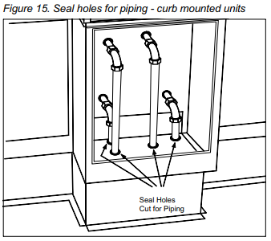
For units with standard base rails, the vestibule is open to the coil section, so all holes must be sealed to prevent air leakage (Figure 16).
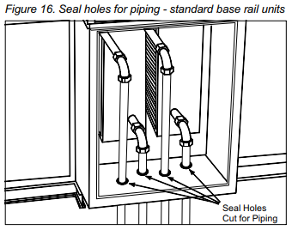
Piping and Coils
Follow the applicable piping design, sizing, and installation information presented in the ASHRAE Handbooks for the design and installation of piping. Observe all local codes and industry standards. Undue stress should not be applied at the connection to the coil headers. Pipework should be supported independently of the coils.
Water Cooling Coils
Note: It is recommended that Glycol be used in water coils for outdoor air handlers. Power failures and other mechanical issues can expose coils to freezing temperatures.
1. Water supply, water return, drain, and vent connections extend through the end panel of the coil section. All connections are labeled on the end panel.
2. Water supply and water return connections are typically male N.P.T. iron pipe.
3. When installing couplings, do not apply undue stress to the connection extending through the unit panel. Use a backup pipe wrench to avoid breaking the weld between the coil connection and the header.
4. Follow the recommendations of the control manufacturer regarding types, sizing, and installation of the controls.
Direct Expansion Coils
1. The coil distributor and suction connection extend through the end panel of the coil section.
2. Check the nozzle in the distributor for proper tonnage.
3. When a thermostatic expansion valve is supplied with the unit, it will be located outside the unit and connected directly to the distributor (except on units with piping vestibules). Do not apply heat to the body of the expansion valve.
4. The thermostatic expansion valve must be of the external equalizer tube type. Connect the 1/4” diameter external equalizer tube provided on the coil to the connection on the expansion valve.
5. Use care when piping the system to see that all joints are tight, and all lines are dry and free of foreign material. For typical refrigerant piping, see the condensing unit product manual.
Steam Coils (Figure 17)
Note: Steam traps should not be placed outdoors.
1. All steam coils in units are pitched toward the return connection.
2. The steam supply and steam return connections are typically male N.P.T. iron pipe and are labeled on the end panel of the coil section. Connections extend through the coil section end panel.
3. When installing couplings, do not apply undue stress to the connection extending through the unit panel. Use a backup pipe wrench to avoid breaking the weld between the coil connection and header.
4. Support piping independently of the coils and provide adequate piping flexibility. Stresses resulting from expansion of closely coupled piping can cause serious damage.
5. Do not reduce the pipe size at the coil return connection. Carry the return connection size through the dirt pocket, making the reduction at the branch leading to the trap.
6. Install vacuum breakers on all applications to prevent retaining condensate in the coil. Generally, the vacuum breaker is to be connected between the coil inlet and the return main, the vacuum breaker should be open to the atmosphere, and the trap design should allow venting of large quantities of air.
7. Do not drip the supply mains through the coil.
8. Do not attempt to lift the condensate when using modulating or on/off control.
9. Size traps in accordance with the manufacturer’s recommendations. Be certain that the required pressure differential will always be available. DO NOT UNDER-SIZE.
10. Float and thermostatic or bucket traps are recommended for low pressure steam. On high pressure steam, bucket traps are normally recommended. Thermostatic traps should be used only for air venting.
11. Bucket traps are recommended for use with on/off control only.
12. Locate traps at least 12 inches below the coil return connection.
13. Multiple coil installation:
A. Each coil or group of coils that is individually controlled must be individually trapped.
B. Coils in series: Separate traps are required for each coil, or bank of coils, in series.
C. Coils in parallel: A single trap may generally be used but an individual trap for each coil is preferred.
D. Do not attempt to lift condensate when using modulating or on/off control.
14. With coils arranged for series airflow, a separate control is required on each bank or coil in the direction of airflow.
15. Modulating steam valves are not recommended on high pressure systems.
16. Modulating valves must be sized properly. DO NOT UNDER-SIZE.
17. Freezing conditions (entering air temperatures below 35°F.):
A. Steam coils are strongly recommended.
B. 5 PSI steam must always be supplied to the coils.
C. Modulating valves are not recommended. Control should be provided by face and bypass dampers.
D. Consideration should be given to the use of two or three coils in series with two position steam control valves on that coil or coils handling 35°F. or colder air. The desired degree of control can be attained with a modulating valve on the downstream coil.
E. Thoroughly mix fresh air and return air before it enters the coil. Also, temperature control elements must be properly located to obtain true air mixture temperatures.
F. As additional protection against freeze-up, the trap should be installed sufficiently below the coil to provide an adequate hydrostatic head to provide removal of condensate during an interruption in the steam pressure. Estimate three feet for each 1 PSI of trap differential required.
G. On startup, admit steam to the coil 10 minutes before admitting outdoor air.
H. Close fresh air dampers if the steam supply pressure falls below the minimum specified.
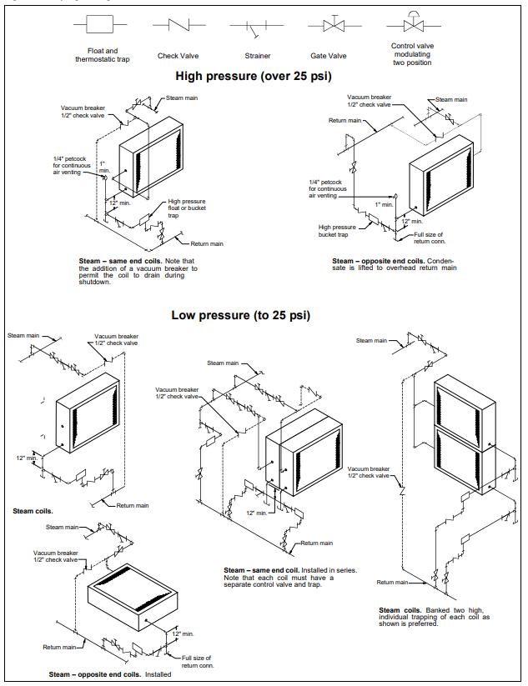
Water Heating Coils
1. The water supply and water return connections extend through the end panel of the coil section. All connections are labeled on the end panel.
2. Water supply and water return connections are male N.P.T. iron pipe.
3. When installing couplings, do not apply undue stress to the connection extending through the unit panel. Use a backup pipe wrench to avoid breaking the weld between the coil connection and header.
4. Follow recommendations of the control manufacturer regarding types, sizes, and installation of controls.
5. Hot water coils are not recommended for use with entering air below 40°F.
6. If fresh air and return air are to be heated by a hot water coil, care should be used in the design of the system to provide thorough mixing before air enters the coil.
7. For preparation of coils for winter operation, see “Winterizing Water Coils”.
Drain Pan Traps
Drain lines and traps should be run full size from the drain pan connection. Drain pans should have traps to permit the condensate from the coils to drain freely. On both blow-through and draw-through units, the trap depth and the distance between the trap outlet and the drain pan outlet should be twice the static pressure in the drain pan section under normal operation for the trap to remain sealed (Figure 18).
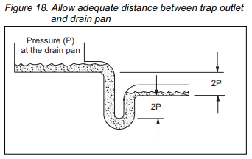
Note: The door panels on some applications have a close clearance over the drain pipes. Extend the drain fitting with a coupling if necessary for door clearance (Figure 19).
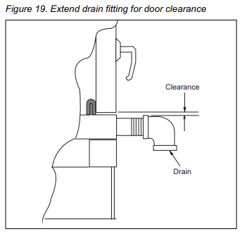
Note: Outdoor drain traps should be made of a material that can withstand freezing temperatures.
Note: Drain traps that dry out can allow cold air to seep into the equipment.
Internal Isolation Assembly Adjustment
On units with internally isolated fan and motor assemblies, the assemblies have been secured for shipment with a tie-down at each point of isolation.
Before operating the unit:
Remove the shipping brackets and tie-down bolts and discard. The shipping brackets located on the opposite drive side of the unit are difficult to access from the drive side of the unit. Either remove them before the unit is assembled or remove the panel on the opposite drive side to gain access (Figure 20).
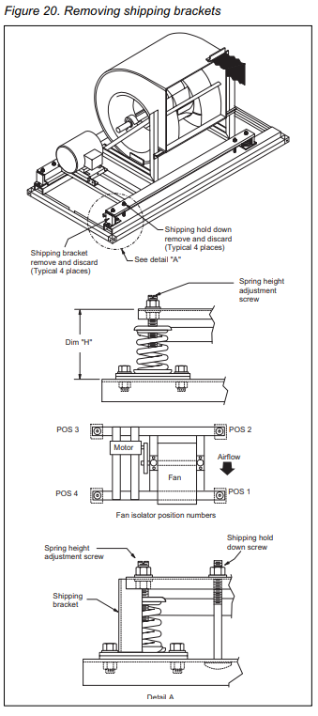
The spring isolators under the four corners of the fan and motor assembly have been factory adjusted while the fan was not running (Table 1). With the unit operating at normal CFM and static pressure, the isolators should all be at the same height opening. If adjustments are required, loosen the 1/2" cap-screw on top of the isolator and turn the adjusting bolt to lower or raise the fan and motor base. Retighten the cap-screw when adjustments are completed.
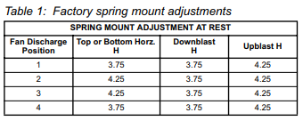
Electrical Installation
1. Electrical services to the fan must correspond to the rated voltage on the motor nameplate and be in conformance with the National Electric Code and local restrictions.
2. The fan section metal frame must be connected to the buildings electrical ground.
3. A door electrical interlock is not provided as standard.
4. Thermal motor protection is external to the unit.
Electrical conduit entrances for units should be located above the bottom of the unit enough to clear components inside but MUST be located below the bottom of the fan motor junction box (Figure 21).
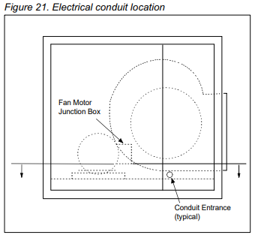
Notice: The base section of each cabinet has a drip pan installed below every panel that drains to the outside frame trough. Any holes cut through the bottom of the unit must also penetrate the drip pan. If holes are cut in the drip pan, they must be sealed to prevent moisture leakage.
Operation Guidelines
Start-Up Checks
When performing startup and service, thorough safety precautions must always be taken. These functions must be performed by trained and experienced personnel.
WARNING: ROTATING FAN CAN CAUSE SEVERE INJURY OR DEATH. BEFORE SERVICING FANS, LOCKOUT AND TAG OUT THE POWER.
WARNING: FIRE/ELECTRIC SHOCK HAZARD. CAN CAUSE PROPERTY DAMAGE, PERSONAL INJURY, OR DEATH. FAN POWER SUPPLY MUST BE WIRED AND MOTOR FRAME GROUNDED IN ACCORDANCE WITH LOCAL ELECTRIC CODES.
WARNING: FAN MOTOR REQUIRES OVERLOAD PROTECTION. FAILURE TO PROVIDE MOTOR OVERLOAD PROTECTION CAN RESULT IN FIRE, PROPERTY DAMAGE, ELECTRIC SHOCK, PERSONAL INJURY, OR DEATH. CONNECT MOTOR TO AN OVERLOAD PROTECTIVE DEVICE RATED IN COMPLIANCE WITH LOCAL ELECTRIC CODES.
CAUTION: DO NOT OVERHEAT FAN MOTOR. HIGH AIR TEMPERATURES IN THE FAN SECTION CAN CAUSE THE FAN MOTOR TO BURNOUT. ON DRAW-THROUGH AIR HANDLERS OR AIR HANDLERS WITH THE FAN SECTION DOWN THE AIR STREAM FROM THE HEATING SECTION, THE DISCHARGE AIR TEMPERATURE OF THE HEATING SECTION MUST NOT EXCEED 104°F. (40°C.).
Before starting up the unit:
Before entering the fan section, make sure that the fan electrical power source is disconnected and locked in the “OFF” position.
1. Check that the unit is completely and properly installed with ductwork connected. Check that all construction debris is removed, and filters are clean.
2. Check that all electrical work is complete and properly terminated. Check that all electrical connections are tight and that the proper voltage is connected. Phase imbalance must not exceed 2%.
3. Ball bearings on the fan shaft and motor are pre-lubricated and do not need grease before startup.
4. Check the tightness of the setscrews in the bearings and fan wheel(s). If retightening is needed, make certain the fan wheel(s) are positioned per (Table 2 or Table 3) and the setscrews are torqued per (Table 6).
CAUTION: Equipment damage due to loose fasteners represents improper startup and equipment abuse. It is not covered by the warranty.
5. Check alignment of fan and motor sheaves and belt tension. Adjust if necessary. Check the tightness of the sheave setscrews and/or cap-screws (Figure 28 and Figure 29).
6. Leak test the thermal system to verify that the connections are tight.
7. Check that the condensate drain is trapped.
8. Rotate the shaft by hand to be sure it is free.
9. Fan startup: Fan should start and run. Observe the rotation. If the fan is operating backward, reverse two legs of the 3-phase supply power.
Note: Variable pitch fan drives are usually provided for operation in the mid-speed adjustment range. However, the drives are usually shipped with the adjustment opened for the minimum fan speed. The drives should be adjusted for the proper airflow (See “Fan Drive Adjustments”).
After first 48 hours of operation:
1. Disconnect and lock the electrical power source. Check the tightness of all bearing, wheel, and sheave setscrews/cap-screws (Table 6).
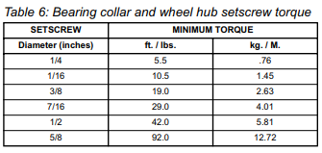
2. Recheck the belt tension and adjust if necessary. Belts tensioned sufficiently to slip one to two seconds at startup will perform satisfactorily, extending life and reducing vibration. If re-tensioning is necessary be certain the sheave alignment is retained.
Fan Wheel Alignment
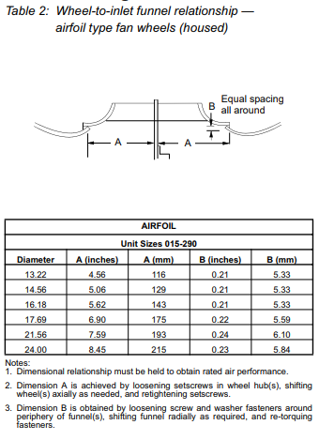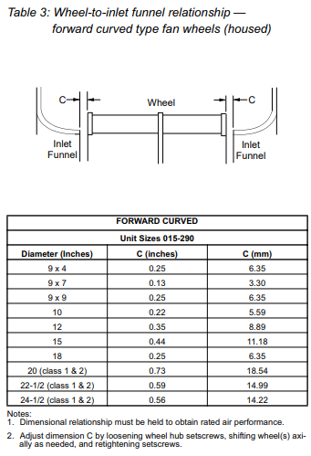
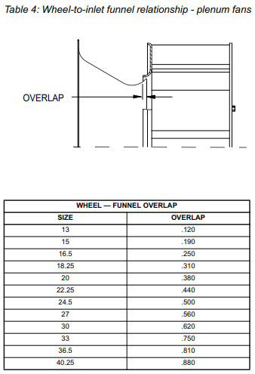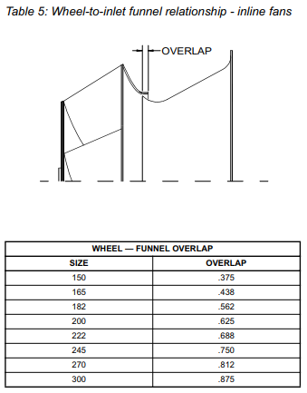
Fan Operating Limits
Do not exceed the operating limits in (Table7). A fan wheel that is operated beyond the RPM limits shown may suffer permanent distortion or fracture. The resulting unbalance may cause severe unit vibration.
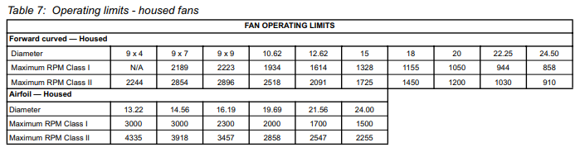
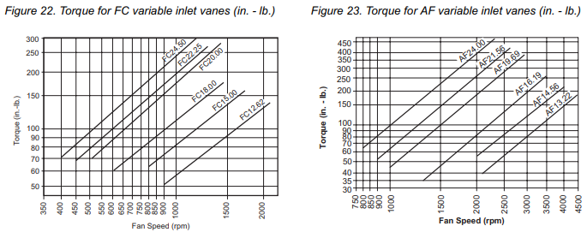
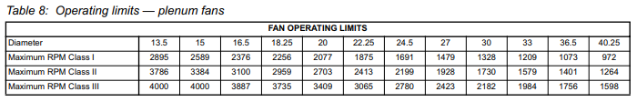
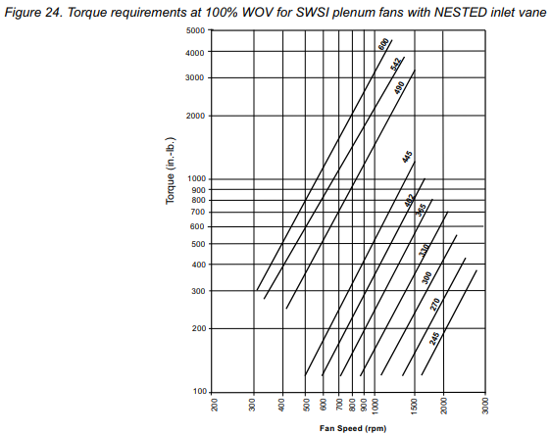
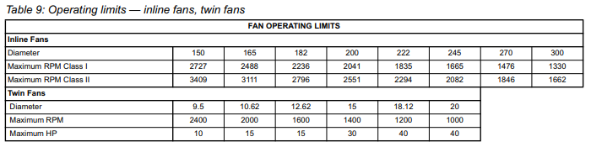
Fan Vibration Levels
Each unit, as shipped, has been trim-balanced to operate smoothly. If excessive vibration occurs after installation, use the accepted industry guidelines for field balancing fans (Table 10).
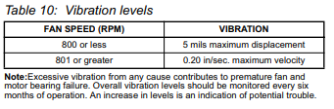
Vibration Causes
1. Wheel imbalance.
A. Dirt or debris on wheel blades.
B. Loose setscrews in wheel hub or bearing-to-shaft.
2. Bent shaft.
3. Drive faulty.
A. Variable pitch sheaves- Axial and radial runout of flanges; uneven groove spacing; out of balance. Also, similar faults in driven sheave.
B. Bad V-belts; lumpy, or mismatched; belt tension too tight or too loose.
4. Bad bearings, loose bearing hold-down bolts.
5. Motor imbalance.
6. Fan section not supported evenly on foundation.
Service and Maintenance
Periodic Service and Maintenance
1. Check all moving parts for wear every 6 months.
2. Check bearing collar, sheave, wheel hub setscrews, sheave cap-screws, and bearing hold-down bolts for tightness every 6 months.
Ball Bearing Lubrication
1. Motor Bearings: All ball bearings are pre-lubricated and do not require addition of grease at the time of installation. However, periodic cleaning out and renewal of grease is necessary. Please note that extreme care must be exercised to prevent foreign matter from entering the bearing. It is also important to avoid over-greasing. Only a high grade, clean mineral grease having the following characteristics should be used.
A. Melting point preferably over 302°F. (150°C.), freedom from separation of oil and soap under operating and storage conditions; and freedom from abrasive matter, acid, alkali, and moisture.
B. Specific greasing instructions are located on a label attached to the fan section door.
2. Fan Shaft Bearings: All ball bearings are pre-lubricated and do not require addition of grease at the time of installation. However, periodic renewal of grease is necessary. Bearings are accessible through the access door in the fan section. Grease fittings are in front of the door opening on the drive end of the blower section. Apply grease slowly until a very slight bleeding of grease from the seal is noted. Tie hinged door(s) open. DO NOT OVER-LUBRICATE. Wipe off any excess grease to prevent overheating.
The lubrication interval varies with the period of operation and temperature of the ambient air. Follow the instructions listed below:
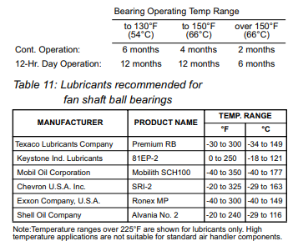
Fan Drive Adjustments
WARNING: ROTATING FAN CAN CAUSE SEVERE INJURY OR DEATH. BEFORE SERVICING FANS, LOCKOUT AND TAG OUT THE POWER.
WARNING: MOVING PARTS. DO NOT OPEN THE HINGED ACCESS DOOR AND SCREW-FASTENED ACCESS PANELS WHILE THE UNIT IS OPERATING. MOVING PARTS AND STRONG SUCTION FORCES CAN CAUSE SEVERE PERSONAL INJURY OR DEATH.
Before entering any fan section, make sure the electrical power source to the fan motor is DISCONNECTED, LOCKED OUT, AND TAGGED OUT.
Do not enter the fan section while the unit is operating to determine the fan speed.
Upon completion of the air balance, it is recommended that the variable pitched motor sheave be replaced with a properly sized fixed sheave. Initially, it is best to have a variable pitched motor sheave for air balancing, but fixed sheaves maintain balancing and alignment more effectively and provide longer belt and bearing life and a vibration free operation.
With the electrical power disconnected, locked, and tagged out, measure the diameter of the V-belt outer surface where it passes around the sheave (pitch diameter). Calculate the fan speed from the motor nameplate RPM.
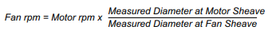
“VM” and “VP” Variable Pitch Key Type Sheaves (Figure 25)
Mounting:
1. All sheaves should be mounted on the motor or driving shaft with setscrews “A” toward the motor.
2. Verify that both driving and driven sheaves are in alignment and that shafts are parallel.
3. Fit internal key “D” between the sheave and the shaft, and lock setscrew “A” securely in place.
Adjusting:
1. Loosen setscrews “B” and “C” in moving parts of the sheave and pull out external key “E”. This key projects a small amount to provide a grip for removing.
2. Adjust the sheave pitch diameter for desired speed by opening moving parts by half or full turns from the closed position. Do not open more than five full turns for “A” belts or six full turns for “B” belts.
3. Replace external key “E” and securely tighten setscrews “B” over the key and setscrews “C” into the keyway in the fixed half of the sheave.
4. Put on belts and adjust belt tension. DO NOT FORCE BELTS OVER GROOVES (See “Drive Belt Adjustment”).
5. Future adjustments should be made by loosening the belt tension and increasing or decreasing the pitch diameter of the sheave by half or full turns as required. Readjust the belt tension before starting the drive.
6. Two-groove sheaves must have both halves adjusted by the same number of turns from closed position to provide the same pitch diameter.
7. Verify that all keys are in place and that all setscrews are tight before starting the drive. Check the setscrews and belt tension after 24 hours of service.
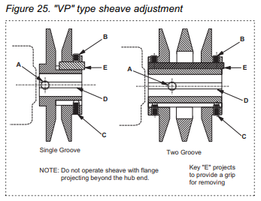
“LVP” Variable Speed Sheaves (Figure 26)
Mounting:
1. Slide sheave on the motor shaft so that the side of the sheave with setscrew “A” is next to the motor, when setscrew “A” is in the hub or barrel of the sheave.
2. When setscrew “A” is at an angle in the center flange “B”, it should be mounted away from the motor so that the outer locking ring and flange can be removed to get to the setscrew.
3. To remove the flange and locking ring:
A. Loosen setscrews “D”.
B. Loosen but DO NOT REMOVE cap-screws “E”.
C. Remove key “F”. Note: This key projects a small amount to provide a grip for removing.
D. Rotate the flange counter-clockwise until it disengages the threads on the sheave barrel.
4. Verify that the driving and driven sheaves are in alignment and the shafts are parallel. When aligning two-groove sheaves, allow room between the sheave and motor to get to cap-screws “E”.
5. Insert key “C” between the sheave and the shaft and tighten setscrew “A” securely.
6. If the flange and locking ring have been removed, when replacing them make sure that the inner and outer flanges are open from the closed position by the same amount as the other flange. This can be determined by accurately measuring the top width of the grooves.
7. Insert key “F”.
8. Tighten setscrews “D” and cap-screws “E”.
9. Put on belts and adjust the belt tension. DO NOT FORCE BELTS OVER THE GROOVES (See “Drive Belt Adjustment).
10. Be sure that all keys are in place and all setscrews/cap-screws are tight before starting the drive. Check and retighten all screws and re-tension belts after approximately 24 hours of service.
Adjusting:
1. Slack off belt tension if the belts have been installed.
2. Loosen setscrews “D”.
3. Loosen but DO NOT REMOVE cap-screws “E”.
4. Remove key “F”. Note: This key projects a small amount to provide a grip for removing.
5. Adjust pitch diameter by opening or closing the movable flanges by half or full turns. Note: Two-groove sheaves are supplied with both grooves set at the same pitch diameter. Both movable flanges must be moved the same number of turns to provide the same pitch diameter for satisfactory operation. Do not open the sheaves more than five turns for “A” belts or six turns for “B” belts.
6. Replace key “F”.
7. Tighten setscrews “D” and cap-screws “E”.
8. If the belts have been installed, readjust the belt tension. If the belts have not been installed, install them and adjust the belt tension. DO NOT FORCE BELTS OVER THE GROOVES (See “Drive Belt Adjustment”).
9. Verify that all keys are in place and all setscrews/cap-screws are tight before staring the drive. Check and retighten all screws and re-tension belts after approximately 24 hours of operation.
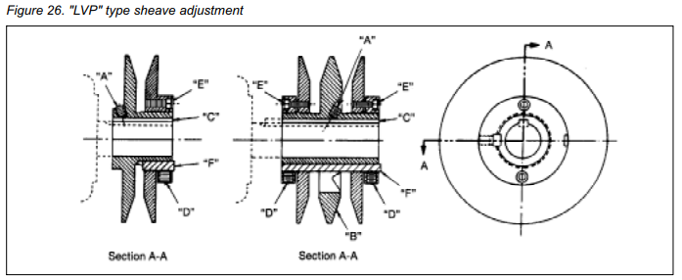
“MVP” Variable Speed Sheaves
Mounting:
1. Verify both driving and driven sheaves are in alignment and the shafts are parallel. The centerline of the driving sheave must be in line with the centerline of the driven sheave (Figure 27).
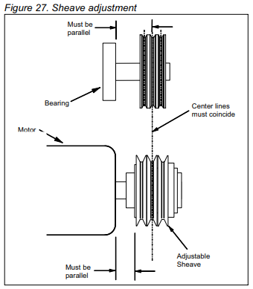
2. Verify that all setscrews are torqued to the values shown in (Table 12) before starting the drive. Check the setscrew torque and belt tension after 24 hours of service.
Adjusting:
1. Adjust the motor base forward to release the belt tension. Remove the belts for easier adjustment.
2. Loosen, but do not remove both locking setscrews “A” in the outer locking ring by using a hex key or a torque wrench with a hex bit.
3. Adjust the sheave to desired pitch diameter by turning the outer locking ring. Use a spanner wrench or drift inserted into the 3 holes that are located 120° apart on the ring.
4. Any pitch diameter can be obtained within the sheave range. One complete turn of the outer locking ring will change the pitch diameter 0.233”.
5. Do not open sheaves more than the following:
A. Do not open “B” sheaves more than 4-3/4 turns for the “A” belts or 6 turns for the “B” belts.
B. Do not open “C” sheaves more than 9-1/2 turns.
C. Do not open “5V” sheaves more than 6 turns.
D. Do not open “8V” sheaves more than 8 turns.
6. Tighten BOTH locking screws “A” in the outer locking ring before operating the drive. Use a torque wrench and tighten to the value shown in (Table 12).
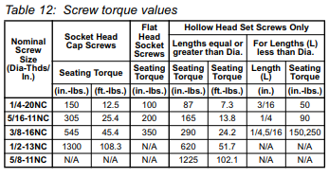
7. Replace the belts and adjust the motor base to tension the belts properly (Figure 29).
8. Do not loosen any screws other than the two locking screws “A” in the outer locking ring when adjusting the sheave pitch. Do not operate the drive until the locking screws have been set to the torque specifications.
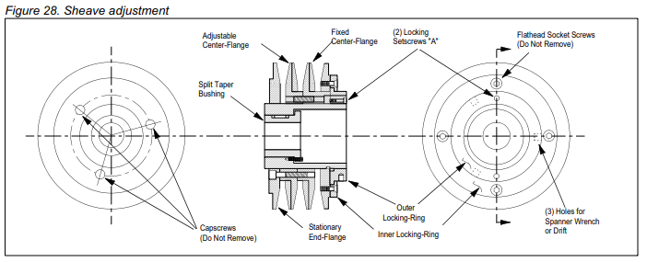
Drive Belt Adjustment
General Rules of Tensioning
1. The ideal tension is the lowest tension at which the belt will not slip under peak load conditions.
2. Check the tension frequently during the first 24-48 hours of operation.
3. Over-tensioning shortens the belt and bearing life.
4. Keep belts free from foreign material which may cause slippage.
5. Make V-drive inspections periodically. Adjust tension if the belt is slipping. Do not apply belt dressing as this could damage the belt and cause early failure.
Tension Measurement Procedure
1. Measure the belt span (Figure 29).
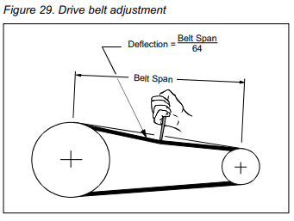
2. Place the belt tension checker squarely on one belt at the center of the belt span. Apply force to the checker, perpendicular to the belt span until the belt deflection equals the belt span distance divided by 64. Determine the force applied while in this position.
3. Compare this force to the values in (Table 13).
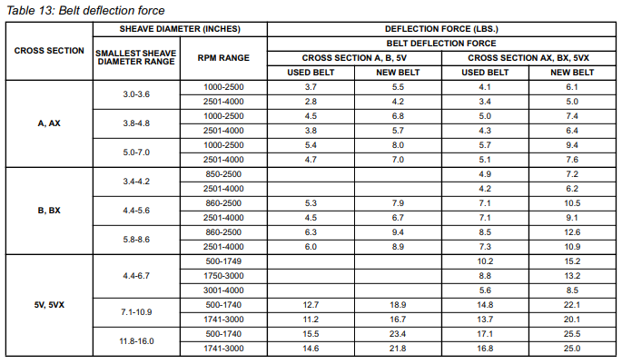
Front Load Filter Option
Front loaded filter options require that the filters be removed and replaced from inside the unit.
WARNING: MOVING BELT AND FAN CAN CAUSE SEVERE PERSONAL INJURY OR DEATH. During installation and filter maintenance:
1. Verify that the belt and fan guards on plenum fan units are always in place.
2. Lock and tag out fans to prevent accidental startup.
3. Do not enter the filter compartment until the fan is completely stopped.
4. Use approved equipment for reaching filters located above normal reach. Do not step on the filter frames or unit components.
5. Floor surfaces must be dry and free of oil or grease.
To remove filters, rotate the wire clips. This will release both the pre-filter and the final filter. When installing the clean filters, check to verify the filters are fully seated in the frame (Figure 30).
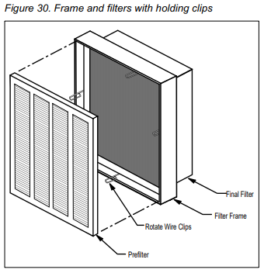
(Table 14) shows the typical filter pressure drop for clean filters at rated air flow and a final pressure drop for front loaded filters.
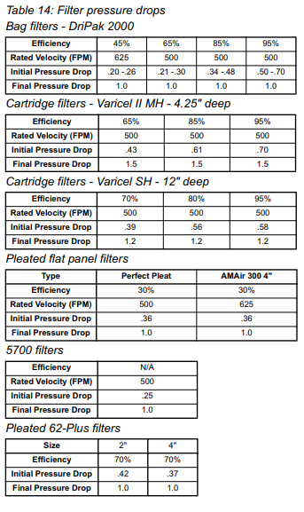
Winterizing Water Coils
Coil freeze-up can be caused by air stratification and failure of outdoor dampers and/or preheat coils. Routing draining of water-cooling coils for winter shutdown cannot be depended upon as insurance against freeze-up. Severe coil damage may result. It is recommended that all coils be drained as thoroughly as possible and then treated in the following manner.
Fill each coil independently with an antifreeze solution using a small circulating pump and again thoroughly drain.
Check the freezing point of antifreeze before proceeding the next coil. Due to a small amount of water always remaining in each coil, there will be a diluting effect. The small amount of antifreeze solution remaining in the coil must always be concentrated enough to prevent freeze-up.
Note: Carefully read instructions for the mixing antifreeze solution used. Some products will have a higher freezing point in their natural state than when mixed with water.
Coil Maintenance
1. The coil must be clean to obtain maximum performance. Check once a year under normal operating conditions and, if dirty, brush or vacuum clean. Use a chemical coil cleaner on multiple row coils. Read and follow the chemical cleaner’s instructions as some cleaners may contain harsh chemicals. Take care not to damage fins while cleaning. CAUTION: FIN EDGES ARE SHARP.
2. Drain pans in any air conditioning unit may have some moisture. Algae, etc., will grow due to airborne spores and bacteria. Periodic cleaning is necessary to prevent this build-up from plugging the drain and causing the drain pan to overflow. Also, the drain pans should be kept clean to prevent the spread of disease. Cleaning should be performed by qualified personnel.
WARNING: CLEAN DRAIN PANS REGULARLY SO MOLD DOES NOT DEVELOP.
3. Dirt and lint can clog the condensate drain, especially with dirty filters. Inspect the drain twice a year to help avoid overflow.
Component Removal and Replacement
See “Access Doors and Panels” for instructions on removing panels and opening fan access doors to remove or replace components.
Fan Section
The fan shaft, motor, and any drive components can be removed and replaced through the access door opening. If required, the side panel can be removed for additional access.
If fan replacement is required, the entire fan assembly can be pulled out the side of the cabinet. The fan assembly includes the fan housing, the bearing support, and the fan base.
To remove the fan assembly, remove the side panels and any intermediate supports (follow instructions for side panel removal). Once the panels and any intermediate supports are removed, disconnect the neoprene bulk head seal that is attached to the fan discharge. Remove the four discharge angles that hold the neoprene canvas in place around the discharge opening. Then disconnect the fan sled from each of the corner mounts and pull the entire assembly out the side of the unit. After the fan sled is out, loosen the fan bearings and pull out the shaft. Disconnect the fan housing from the fan sled and bearing support by removing the attaching bolts.
Replace the new fan, reconnect the shaft and bearings, and put the fan assembly in the cabinet. Replace the panels and fasteners.
Coil Removal and Replacement
Removing Single Coils
Note: Single coils are bolted to the unit on the connection end. The connection end is held in place with a clamp (Figure 31).
1. Disconnect all piping and remove the brass plugs for the vents and drains located in the connections. Remove all screws and remove the access panel.
2. Remove the screws holding the coil in place then lift and pull the coil out the side.
Installing Single Coils
1. Slide the coil through the opening in the coil section onto the bottom coil rests. Coils must be placed up against the coil bulkheads to prevent any air bypass around the coil. Once the coil is in place, fasten the coil to the section. Caulk the seams between the coil casings and bulkheads (Figure 31).
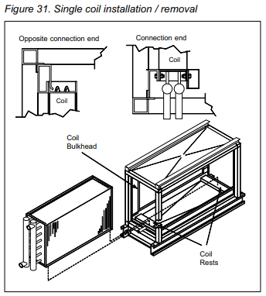
2. If this is an additional coil being installed and not a replacement, you must locate the coil supply and return connections dimensionally. Carefully drill holes in the end panels of the unit.
3. Remove the brass plugs for the vents and drains on the connections. Slip the panel over the connections. Replace the brass plugs and panel fasteners.
Removing Stacked Coils
Note: Top and bottom stacked coils are held together with a steel plate and screws on one side and a drain trough and screws on the other side. Remove the plate and trough before removing the coils. The coils cannot be removed when they are attached together (Figure 32).
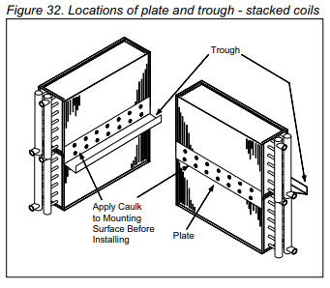
1. Disconnect all piping and remove the brass plugs for the vents and drains located in the connections. Remove all the screws and remove the access panel.
2. Remove the bolts holding the coil in place and then lift and pull the coil out the side.
3. Remove the steel plate and the drain trough that holds the coils together.
4. Remove the bolts on both ends of the top coil holding it in place, then lift and slide the coil out.
5. Remove the bolts on both ends of the bottom coil holding it in place, then lift and slide the coil out.
Installing Stacked Coils
1. Slide the bottom coil through the opening in the coil section onto the bottom coil rests. The coil must be placed up against the coil bulkheads to prevent any air bypass around the coil. Once the coil is in place, bolt the coil to the section.
2. Slide the bottom coil through the opening. The coil must be placed up against the coil bulkheads to prevent any air bypass around the coil. Once the coil is in place, bolt the coil to the section.
3. Caulk the mounting surface of the steel plate and install the plate on the coils.
4. Caulk the mounting surface of the drain trough and install the drain trough on the coils.
5. Caulk the seams between the coil casings and block-offs.
6. Connect all piping and install the brass plugs for the vents and drains located in the connections. Install the access panel.
Removing and Installing Staggered Coils
Staggered coils have two banks of coils positioned a few inches apart in the direction of airflow. Both coils are secured to the unit on the connection and opposite connection end of the unit.
1. Disconnect all piping and remove the brass plugs for the vents and drains located in the connections.
2. Panels on both the connection and opposite connection end of the coil section need to be removed to access bolts holding the coils in place. Each coil is held in place with bolts located in the corners of the coil side plates. Remove the bolts then lift and pull the coil out the side.
3. The bottom coil is fastened to the air block off plate. The screws attaching this plate to the coil must also be removed. Once the fasteners holding the coil in place are removed, the coil can be pulled out of either side of the unit.
4. Install the coils in reverse order of removal.
General Description
Curb-Ready Air Handler
Coil Company outdoor air handler units can be equipped with a base assembly that provides a mechanical fit and seal to the building’s Island Roof Curbing. Coil Company outdoor air handlers must be ordered from the factory with a curb-ready base to mount units on a roof curb. The curb-ready base is not available for field application to the Air Handler.
(Figure 1) shows various base rail options for Coil Company outdoor air handlers. Units that do not have base rails and units with standard base rails must NOT be used with open curbs of any type.
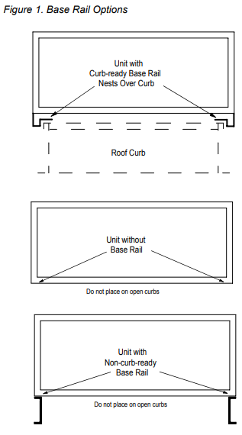
The information provided in these instructions describes the curb kits that are ordered and provided with the Coil Company outdoor air handler. The curb kits are intended to be installed as described and are not intended to be modified or used in conjunction with other curb-mounting features or apparatus.
The dimensional and support requirements are outlined to provide a basis for field designed and applied roof curbs. It is important that the weight and strength factors be carefully followed when applying this roof curb and any curbs that may be field designed.
The curbing must support the air handler uniformly to keep the cabinet square and true. Uneven curbing support can cause distortion of the cabinet and the door openings.
Unit Location
The structural engineer should be involved to verify that the roof has adequate strength and ability to minimize deflection. Extreme caution should be taken when using a wooden roof structure. Units should also be located away from building flue stacks or exhaust ventilators to prevent possible entry of contaminated air through the outside air intake. Ample space should also be provided around the unit for service clearance.
Locating the unit away from occupied spaces and over utility areas, corridors, and auxiliary spaces will help reduce the transmission of sound and vibration to occupied spaces. A concrete deck or pad is recommended when the unit is located over an occupied space where good acoustics are essential.
Curbing Kit
The Coil Company air handler roof curb kit is shipped unassembled and requires field assembly and attachment to the field designed building structural support. The building structural supports for curb mounted units must be approved by qualified individuals. It is important to follow all building codes and roofing standards.
The unit dimensions, weights, and component details are provided within the submittal documents and are unique for each unit. The submittal documents also indicate the functional components within the air handler. While the total weight of each unit section is shown in the submittal documents, the locations of coils, motors, and fans can cause part of the load to be concentrated in one area of an air handler section. Appropriate safety factors should be used to account for the weigh distribution in determining structural load.
Allowance must be made for routing the air ducts through the roof curb. Refer to the submittal data for each unit for the proper dimensions of duct openings prior to installing ductwork. (Figure 2) shows a typical submittal drawing for a curb-ready Coil Company air handler. The unit submittal drawing illustrates the roof curb layout on the unit. The drawing shows the outline of the air handler unit, the outside dimension of the curbing top flange, and the inside dimension of the curbing. The Coil Company units may have piping vestibule sections included as part of the unit selection. The roof curb will also have a vestibule curbing section attached to it. The submittal drawing shows the location and dimensions for the piping vestibule.
The submittal drawings also show the locations and dimensions of the air duct passages in the roof curb. the roof curb may be ordered as a unit option or it can be field supplied. (View A) shows a side view of the cabinet and (View B) shows an end view. If the unit is ducted in the middle (not adjacent to the curb), no allowances are required (View C).
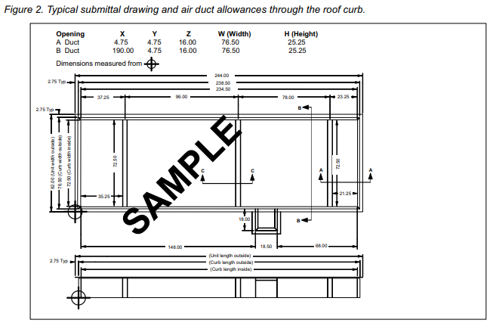
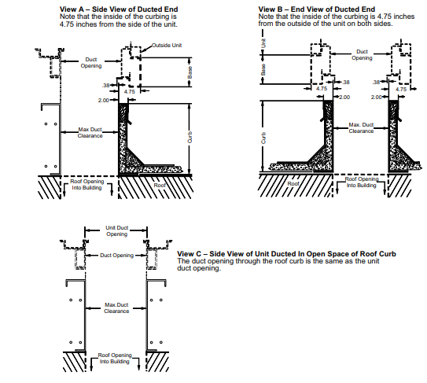
(Figure 3) illustrates the features of the roof curb. Intermediate support channels are provided for support of the supply and return air ducts. If the curbing is field supplied, the duct supports can be provided in accordance with the installation requirements.
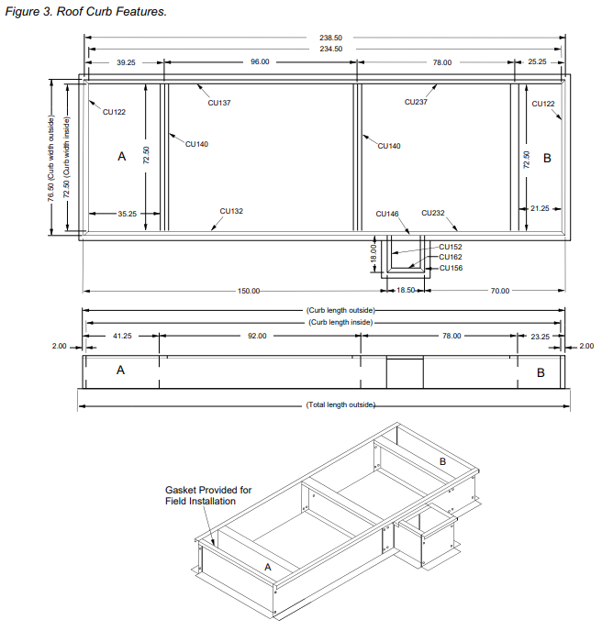
Intermediate supports are provided in the curb assembly at all points where the curb rails require two sections to be joined. For field provided roof curbs, it is recommended that the intermediate supports be incorporated as appropriate for lateral rigidity of the roof curbs.
Intermediate supports are also provided on roof curbs that are over 107” wide. These supports are required at all points where the roof curb sides are joined. Support is also required at the entering and leaving edges of cooling coil sections and fan sections. These intermediate supports are required on all wide unit curbs to provide support to the unit across the open span of the curb.
Curbing Kit Assembly
The weight of the unit is concentrated and supported at the inside wall of the roof curb. The structural system of the building and the interface with the curb must provide support at the points of concentrated loads (Figure 4).
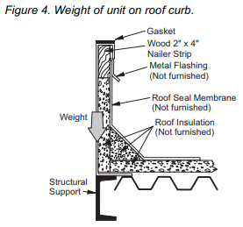
Each curb kit contains a hardware package. The package contains 3/8-16 x 1” bolts and nuts for assembly of the curb. Two 1/4-20 x 1/2" screws are included when the unit has a vestibule. Rolls of gasket are included to cover the top surfaces of the curb and supports.
The hardware kit includes a layout and assembly drawing of the curbing with a sketch of the assembly.
Compare the curb layout drawing to the submittal documents for the air handler to confirm that the details match.
(Figure 3) illustrates a typical layout drawing of the roof curb. Note that each air handler will have a dedicated drawing that corresponds with the features that are included in the unit.
The curbing parts should be laid out according to the assembly drawing. The drawing shows dimensions of the parts and locations on intermediate cross members. The curb parts have labels attached that correspond with the locations of the parts. Parts that are identical have the same part numbers. End parts have number CU122 and center supports have number CU140.
The side supports are shown with sequential numbers CU137, CU237, and so on for parts on one side of the drawing. Likewise, parts on the other side have sequential numbers CU132, CU232 in progression. The curb parts for the vestibule are marked with labels CU152, CU156, and CU162.
The dimensions for the locations of all parts are shown and should be checked carefully for proper assembly order.
Assemble the curb with the 3/8” diameter bolts and nuts that are provided. Always check the dimensions of the curb before final installation to the roof and building structure. Also check to be sure the curb is square and level.
Roof Curbs with a Vestibule Assembly
Note: The vestibule assembly channel, part number CU146 must be attached to the vestibule curb assembly before the vestibule assembly is attached to the main roof curb. Use two 1/4" x 1/2 screws to attach the channel.
The vestibule assembly is then attached to the main roof curb by sliding the rear vertical flange of the vestibule curb under the lip of the main roof curb. Apply sealant and gasket material after the vestibule curb is in place (Figure 5).
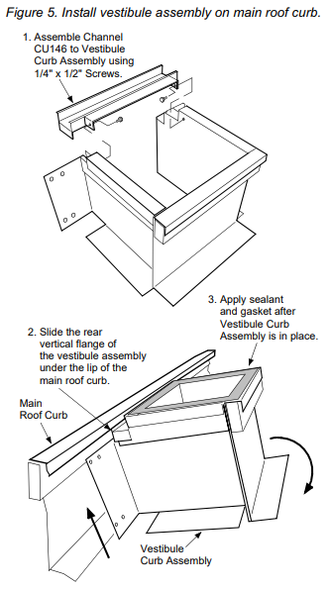
Prepare the Unit for Installation on Curb
THE UNIT MUST BE LIFTED AS INDIVIDUAL SECTIONS ONLY. Some sections require removal of the lifting bracket to allow mating of the adjacent sections (Figure 10).
A length of “D” gasket is attached to each section. This gasket MUST be installed to the unit base section as shown in (Figure 6).
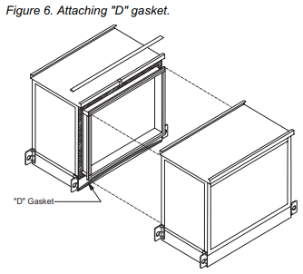
IMPORTANT: The gasket is to be installed in an arc shape with the ends lower than the center so that any moisture that may reach the gasket will be drained to the outside of the unit.
Apply a bead of sealant to the complete perimeter of the mating surface that has the splice collar projecting from the frame. Use the frame as a guide as illustrated in (Figure 7).
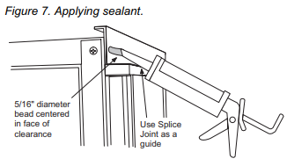
Install Unit on Roof Curb
Check to see that all lifting brackets are secure and that the rigging cables and straps are clear of door handles or any other appendages of the unit.
The units have 2” interlocking splice collars at each mating face. Care must be used so that the flanges engage as the unit sections are mounted together. The units must be set tightly together during lifting as the curb gasket will grip the unit base and make moving the unit difficult.
A hardware package is included in each unit section that contains the bolts and nuts for fastening the unit sections together. Be sure to locate the hardware before the unit is placed over the open roof curb.
Fasten each section at both the bottom and the top using the bolts and hardware before setting the next section in position (Figure 8 and Figure 9).
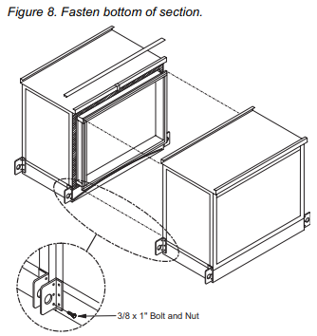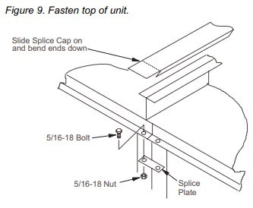
Units with vestibules must be handled so that the lifting bracket can be removed after the unit is placed on the curbing. Remove the lifting bracket that projects inward over the curbing. Save the self-tapping bolts. When the adjacent section is placed in position, use self-tapping bolts to secure the bases together (Figure 10).
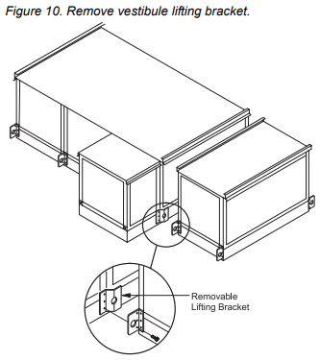
Complete the cabinet by placing sealant over any areas that appear to have remaining gaps. Install the cabinet top strips.
Assemble and install all air hoods in accordance with the instructions that are provided with the hood.
Installation of Piping and Wiring
Be sure that all piping, wiring, and control penetrations that are made through the unit panels and floors are thoroughly sealed on both the inside and outside of the cabinet.
NOTICE: The base section of each cabinet has a drip pan installed below every panel that drains to the outside frame trough. Any holes cut through the bottom of the unit must also penetrate the drip pan. If the holes are cut in the drip pan, they must be sealed to prevent moisture leakage.
A single metal thickness pan is provided in the bottom of the vestibule. The pan can be removed if necessary. If the holes are cut into the pan for piping passage, the holes must be sealed to prevent moisture leakage.

